People’s Names / Place Names / Maps
Anglo-Saxon Kingdoms
The Anglo-Saxons lived in early medieval England; their language was called Old English. There were several kingdoms in Anglo-Saxon England, the biggest of which were Wessex, Mercia, and Northumbria.

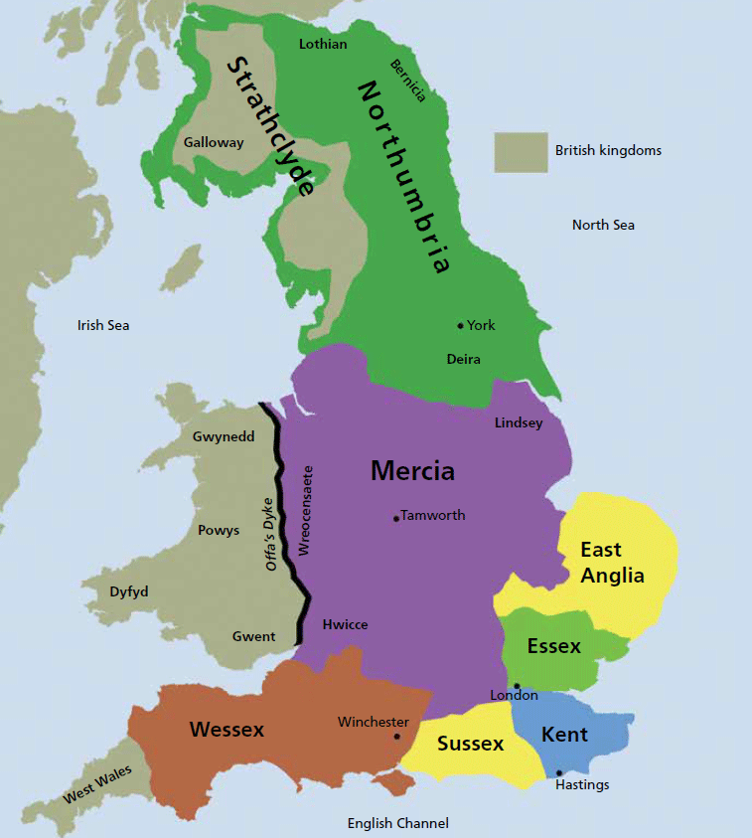
[Source: https://vikings.fandom.com/wiki/England?file=England.gif]

Question: Which English cities and towns have you visited? And which Anglo-Saxon kingdom would those places have been in?

2) Anglo-Saxon Place-Names
The Anglo-Saxons did not often use maps themselves, but they still gave names to many places. Many of the names they gave to places back then are still the names that we use today.
Question: Why is it useful for towns and villages to have names? Why do streets have names? What do we need place-names for?
Question: If you had to name a place, what would you name it after? Do you and your friends or family have your own names for some places?

Here are some of the most important Old English building blocks that our place-names have in them:
Old English Place-name Elements
-bury (e.g. Wendlebury) from Old English burh (castle, fortification)
-cot (e.g. Didcot) from Old English cott (cottage)
-don (e.g. Swindon) from Old English dun (hill)
-ey (e.g. Godney) from Old English ieg (island)
-ham (e.g. Birmingham) from Old English ham (home, homestead)
-hithe (e.g. Rotherhithe) from Old English hyþ (wharf)
-hurst (e.g. Staplehurst) from Old English hyrst (wooded hill)
-ing (e.g. Reading) from Old English -ingas (people of, followers of)
-ley (e.g. Crawley) from Old English leah (woodland clearing, meadow)
-low (e.g. Hounslow) from Old English hlæw (hill, grave mound)
-stead, sted (e.g. Stansted) from Old English stede (place)
-stow (e.g. Chepstow) from Old English stow (place)
-ton (e.g. Castleton) from Old English tun (enclosure, farmstead, town)
-wich (e.g. Ipswich) from Old English wic (settlement)
-wold (e.g. Southwold) from Old English weald (high woodland)
-worth (e.g. Knebworth) from Old English worþ (enclosure, habitation, place)

Quiz: Can you work out what the place-names listed above mean? Here are some clues you’ll need: Some Anglo-Saxons were called Wændla, Dudda, Goda, Beorma, Reada, Gip, and Cnebba. Swin means ‘pig’. Hryþer means ‘cattle’. Stapol means ‘wooden post’. Crawe means ‘crow’. Hund means ‘hound, dog’. Stan means ‘stone’. Ceap means ‘market’.
[Answer: Wendlebury = Wændla’s Castle; Didcot = Dudda’s Cottage; Swindon = Pig Hill; Godney = Goda’s Island; Birmingham = Home of Beorma’s People; Rotherhithe = Cattle Wharf; Staplehurst = Hill of the Wooden Poles; Reading = Reada’s People; Crawley = Crow Meadow; Hounslow = Burial Mound of the Dog; Stansted = Stone Place; Chepstow = Market Place; Castleton = Castletown; Ipswich = Gips’s Settlement; Southwold = Southern Woodland; Knebworth = Cnebba’s Place]
Question: So what kind of words do you get in these place-names?
[Answer: People’s names, landscape words (hill, stream, wood); building and settlement names (house, village, town), animal and plant names.
Question: What kind of words do you not get in place-names? Why not?
[Answer: Cars, machines, railway stations, airports, windfarms. Those hadn’t been invented yet in Anglo-Saxon times when most of our place-names were first given to places].
Question: If ‘ham’ means ‘home’, and -ing- means ‘followers of’, then what do the following names mean?:
Beormingaham, Snottingaham
[Answer: Home of Beorma’s followers; Home of Snota’ Followers (the ‘S’ in this place-name got lost at some point!)
So who were Beorma and Snot? And all the other people, Wændla, Dudda, Goda, Beorma, Reada, Gip, and Cnebba? The answer is: We don’t know; probably powerful leaders after whom some places were named. There is a lot that we don’t know about the Anglo-Saxons; sometimes we just know the name of a person, but not that much more about them, because they lived such a long time ago and all the information got lost.

3) Old English Versions of Modern Place-Names
Here’s a map of the southern and eastern part of England with Old English place-names. Can you find your nearest big town on the map? Can you find London, Canterbury, Oxford, Lincoln, Nottingham, Leicester, Lichfield, Derby, Buckingham?

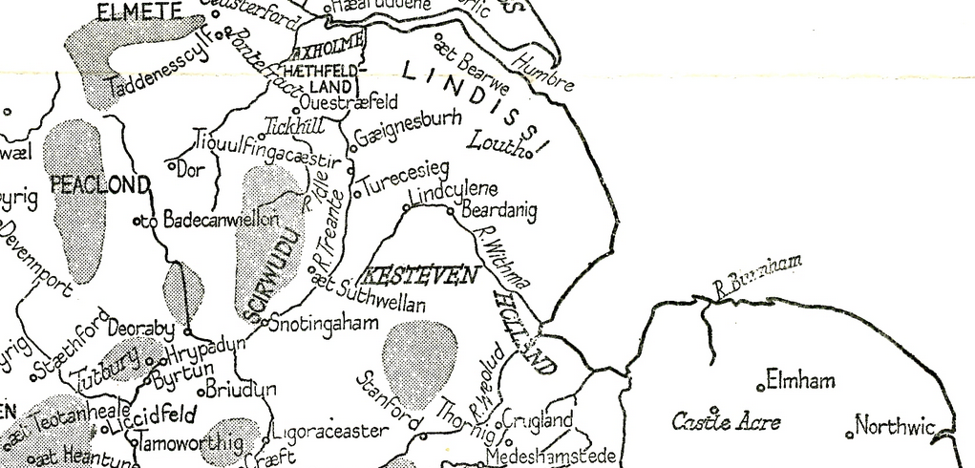
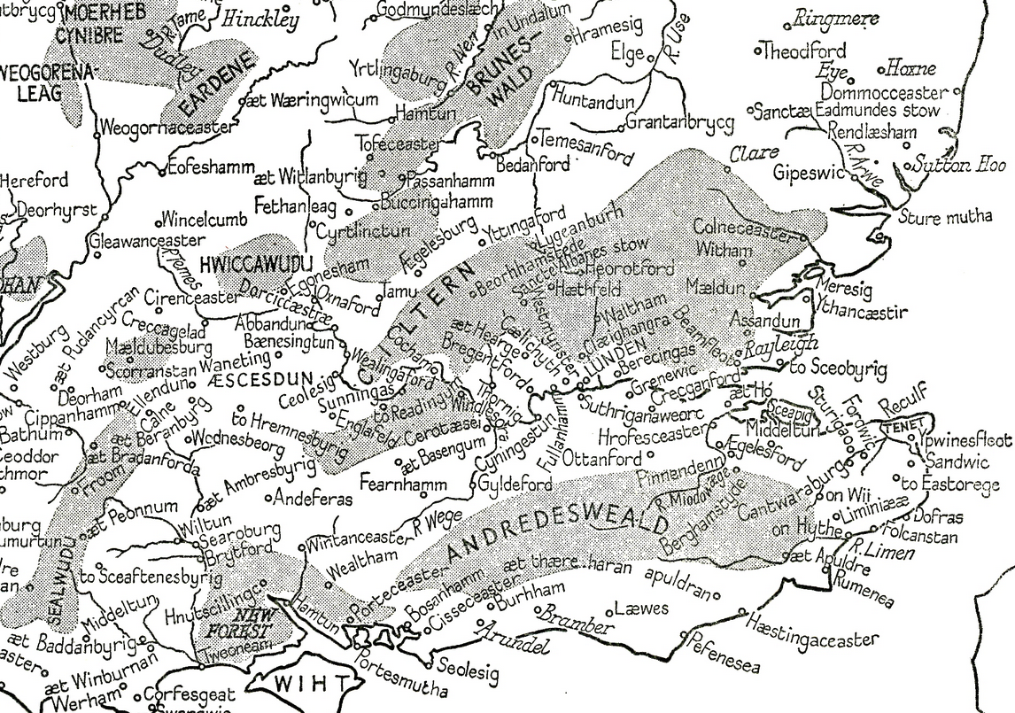
[Source: F. Stenton, Anglo-Saxon England, 3rd edn (Oxford, 1971)

4) Anglo- Saxon Personal Names
People also had names back in Anglo-Saxon times, but they didn’t have a first name and a family name, like we do. They usually just had one name. Anglo-Saxon towns and villages weren’t very big, and not that many people lived in them. So there probably weren’t too many people with the same name living in the same village, and even if there were, it wasn’t too confusing to have more than one person called with the same name. (How many people might live in a big modern city called ‘John’, or ‘Mohammed’ or ‘Sarah’? This is why we need family names in modern times.)

Here some more examples of Old English names:
Edgar
Edwin
Alfred
Wulfstan
Edmund
Hilda
Edward
Hrothberht
Æthelthryth

Question: Which of these names are still used today?
[Answer: quite of few of them: Edgar, Edwin, Alfred, Edmund, Hilda. Some are now spelled differently, Hrothberht = Robert, Æthelthryth = Audrey]

Quiz: Many Anglo-Saxon names mean something. Can you work out what the names given above mean? Here some clues:
ælf = elf
æthel = noble
beorht = bright
cuþ = famous
ed, ead = happy, rich
gar = spear
hild = battle
hroth = glory, fame
mund = protection
ræd = advice
ric = strong
stan = stone
þryth = strength
weard = leader, guardian
win, wine = friend
wulf = wolf
[Answers: Happy Spear, Happy Friend, Elf Advice, Wolf Stone, Happy Protection, Battle Woman, Happy Leader, Glory Bright, Noble Strength]

